**Homework 2**

**Please submit this document to iCollege by 2021/2/21 11:00pm. Late submission will not be accepted.**

Note: You should solve the questions without the help of Python or NumPy, except you are asked to use them.

After you finish the homework, please fill in the blank below. (**2 points**)

**The actual time you spent on this homework: 1 hour**

1. Solve matrix multiplication problems. Show your work. (15 points)

Validate your results with numpy (using A.dot(B) method) and show the screenshots. (9 points)

(a).



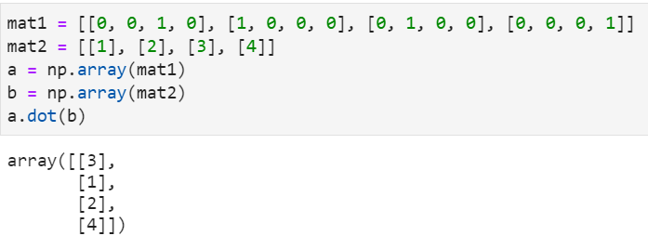

(b).



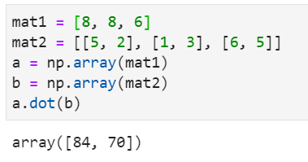

(c).







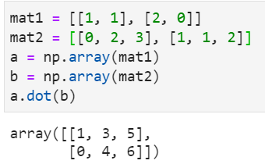

1. List three benefits of using NumPy. (6 points)

Numpy arrays uses significantly less memory to store data than the conventional Python lists.

There are many in-built mathematical functions in Numpy that take significantly lesser time than conventional loops and functions in Python.

Numpy also has inbuilt functions to dynamically reshape multidimensional arrays to linear lists and vice-versa.

1. Suppose you have a Git repo HW2. You just created a file named hw2.docx and you wanted to push it to the remote sever. Describe how you can make it. (10 points)

The commands you may use:

git add

git commit

git pull

git push

git status

git status (This is to check what is going on)

git add hw2.docx

git commit -m ‘Pushed the file.’

1. Which of the following Python types are mutable? (6 points)

list, tuple, int, float, dict, bool, str

List and Dict are mutable.

1. What are the outputs of following codes? (6 points)
2. A picture containing graphical user interface

   Description automatically generated

f(3) = 0

a is 0

1. A picture containing text

   Description automatically generated

f(3) = 18

a is 0

1. List three different types of Python Exceptions. For each Exception, write codes which could cause the Exception. (6 points)

For example,

**Exception type: ZeroDivisionError**

**Code:**

**1/0**

Types of exception:

Exception type: IOError

Code: f = open(‘filethatdoesntexist.txt’, ‘r’)

Exception type: OverflowError

Code: 3.0**10101

Exception type: NameError

Code: b = 6

print(a)

1. List five numpy data types. (5 points)

int, boolean, complex float, float, string.

1. Suppose gArray is a NumPy array. Explain the meaning of following codes and evaluate them manually. (12 points)

1. gArray[1:2, 2:3]: This code segment attempts to print the last element/columns of the second row, because the first index concerns rows and the second index concerns the columns.

Output: array([[61.]])

1. gArray[5:, :1]: This code segment attempts to print the first column of all rows in the array starting from the 6th row.

Output: array([[70.], [88.], [67.], [82.], [94.]])

1. gArray[::5, ::2]: This code segment attempts to print the first and last element of every 5th row after the first row.

Output: array([[79., 60.], [70., 96.]])

1. gArray[gArray[:,0] > 94]: This code segment attempts to print the rows where the first element is greater than 94.

Output: array([[95., 60., 61.], [99., 67., 84.]])

1. List five file open modes and explain the meaning of them. (Hint: Find the answer in slides *6 Text Data, File IO*) (5 points)

‘r’ or ‘t’: This opens the file in read mode, where it can read the contents of the file. File will not be created if it doesn’t exist.

‘w’: This opens the file in write mode, where it can write contents to the file (any existing data is overwritten). File will be created if it doesn’t exist.

‘a’: This opens the file in append mode, where it can add contents to the file (any existing data is not overwritten). The file will be created if it doesn’t exist.

‘r+’: This opens the file in reading and writing mode, where you can read the file and overwrite it. The file needs to exist for this, or else it will not be created.

‘b’: This opens the file in binary mode.

1. What is the difference between the File methods *readlines()* and *readline()* ? (Hint: Find the answer in slides *6 Text Data, File IO*) (6 points)

readlines(): This reads the data in the file by lines, one line after the other. This goes all through the file, from the start to the end. It also returns the list of lines.

readline(): This reads the data in the file from the cursor to the end-of-line character. It does not return the lines.

1. What is the absolute pathname of **Cano** folder? If your current working folder is **Shared** folder, then what is the relative pathname of **messi** folder? (Hint: Find the answer in slides *6 Text Data, File IO*) (6 points)

root folder

/

Applications

Users

bin

var

Firefox.app

Mail.app

Shared

messi

Contents

MacOS

Canon

Absolute pathname: /Users/Shared/Cano

Relative pathname: ../messi

1. What is the output of **'{:7.2f}'.format(100.5)** ? Explain the meaning of **{:7.2f}**. (Hint: Find the answer in slides *6 Text Data, File IO*) (6 points)

This would print “ 100.50.” {:7.2f} is an expression that reserves 7 spaces for the field and displays 100.5 to exactly 2 decimal places. There would be 1 space and 6 spots for the ‘100.50.’

**The actual time you spent on this homework:**

Fill in the blank in page 1.